LAB REPORT实验报告
Lab Title | Binary Search Tree |  |  |  | Lab No.
Stud. Name | 蒋云翔 | Major | CST |  | Class
Student ID | 2022102330 |  | Date | 2023/10/9
Lab description/objectives:
Define the binary search tree ADT. Program to realize the creation, search, insertion
and deletion algorithms for binary search trees:
(1) Given an ordered key sequence, create corresponding binary search tree with
lowest height.
(2) Given a binary tree, check whether the tree is a binary search tree.
(3) Program to realize insertion operation into a binary search tree.
(4) Program to realize deletion operation from a binary search tree.
(5) Write a main function to use the binary search tree ADT. Design many testing cases
and check whether the operations are executed properly.
Source code:
#include<stdio.h>
#include<stdlib.h>
#include<stdbool.h>

typedef int KeyType;
typedef struct node {
KeyType data;
struct node* lchild, * rchild;
} BSTNode;
typedef BSTNode* BSTree;

// 创建二叉搜索树
BSTree CreateBST(KeyType A[], int start, int end) {
int mid = (end + start) / 2;
BSTNode* bt;
if (end < start) return NULL;
bt = (BSTNode*)malloc(sizeof(BSTNode));
bt->data = A[mid];
bt->lchild = CreateBST(A, start, mid-1); //根据所给代码进行修改 原为mid 应改为mid-1
bt->rchild = CreateBST(A, mid + 1, end);
return bt;
}

// 判断二叉树是否为二叉搜索树
bool IsBST(BSTree tree) {
if (tree == NULL) return true;
if (tree->lchild != NULL && tree->lchild->data > tree->data)
return false; // 左子树中有节点的值大于根节点的值
if (tree->rchild != NULL && tree->rchild->data < tree->data)
return false; // 右子树中有节点的值小于根节点的值
if (!IsBST(tree->lchild) || !IsBST(tree->rchild))
return false; // 左子树或右子树不是二叉搜索树
return true;
}

// 插入节点到二叉搜索树
void InsertNode(BSTree* tree, KeyType key) {
if (*tree == NULL) {
*tree = (BSTNode*)malloc(sizeof(BSTNode));
(*tree)->data = key;
(*tree)->lchild = (*tree)->rchild = NULL;
}
else {
if (key < (*tree)->data)
InsertNode(&(*tree)->lchild, key);
else if (key > (*tree)->data)
InsertNode(&(*tree)->rchild, key);
}
}

// 删除节点从二叉搜索树
int DeleteNode(BSTree* tree, KeyType key) {
if (*tree == NULL) return 0; // 节点不存在
if (key < (*tree)->data)
return DeleteNode(&(*tree)->lchild, key);
else if (key > (*tree)->data)
return DeleteNode(&(*tree)->rchild, key);
else {
// 找到要删除的节点
BSTNode* p;
if ((*tree)->lchild && (*tree)->rchild) {
// 被删除节点有两个子节点
p = (*tree)->rchild;
while (p->lchild)
p = p->lchild;
(*tree)->data = p->data; // 用右子树中最小的值代替被删除节点的值
return DeleteNode(&(*tree)->rchild, p->data); // 在右子树中删除最小值的节点
}
else {
// 被删除节点有一个或没有子节点（可以统一操作）无子节点的node两个两个child都是NULL 不影响操作
p = *tree;
if ((*tree)->lchild == NULL)
*tree = (*tree)->rchild;
else
*tree = (*tree)->lchild;
free(p);
return 1;
}
}
}

// 打印二叉搜索树(延用binary tree)
void PrintBST(BSTree b)
{
if (b != NULL)
{
printf("%d", b->data);
if (b->lchild != NULL || b->rchild != NULL)
{
printf("(");
PrintBST(b->lchild);
if (b->rchild != NULL) printf(",");
PrintBST(b->rchild);
printf(")");
}
}
}

// 主函数，测试二叉搜索树的操作
int main() {
KeyType A[] = { 1, 2, 3, 4, 5, 6, 7, 8, 9 };
BSTree bst = CreateBST(A, 0, 8);

printf("Binary Search Tree: ");
PrintBST(bst);
printf("\n");

printf("Is BST?: %s\n", IsBST(bst) ? "Yes" : "No");

InsertNode(&bst, 10);
InsertNode(&bst, 0);

printf("After insertion: ");
PrintBST(bst);
printf("\n");

DeleteNode(&bst, 5);

printf("After deletion: ");
PrintBST(bst);
printf("\n");

return 0;
}

Program outputs:
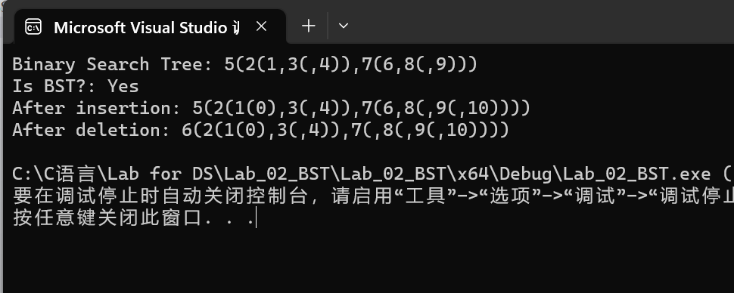

Analysis:
Time complexity of each function:
- CreatBST: O(n) （n is the number of nodes in the tree!!!）
- IsBSTL: O(n)
- InsertNode: O(logn)
- DeleteNode: O(logn)
- PrintBSTL O(n)

